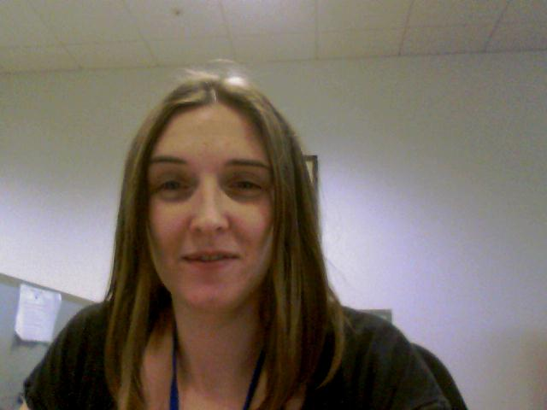 | Carmel  Mobile Application Developer  Age 26  “I want to understand how to leverage Curam to develop mobile applications for Government agencies to provide their clients with access to their data and agency services.”
Background Information

Carmel is Mobile Application Developer working with IBM lab services on a project for the Ministry of Social Development (MSD), New Zealand. She has worked in this role for the past 3 months, but has been part of other Cúram projects within the ministry prior to this, as a software developer. Before Carmel joined IBM lab services, she worked for a technology company; her role was focused on providing bespoke software including mobile application solutions in for variety of industries in New Zealand and Australia. She has good technical knowledge and understanding of standards, code and best practices.

MSD has Cúram in place as a solution to modernise and improve its various service delivery lines and has many projects in the pipeline, some which have completed. Carmel is part of a team who are all based in the National office in Wellington. The team includes project advisors, business analysts, a database administrator, an integration architect, software developers and testers. Carmel is primarily involved in mobile strategy enablement. She carries out all development work required as part of this.

MSD’s mobile strategy is already behind the curve by industry standards. The team is under pressure to get an offering up and running within budget as soon as possible, and don’t have a lot of time to get up to speed. Carmel is a certified Cúram developer and has reasonable knowledge of Cúram from when she worked on a project last year (within MSD). Whilst she has worked in the standard Cúram development environment she has never developed a Cúram mobile application before. (?training here with short description)

Job Responsibilities

- Works with the business team to understand the requirements of the mobile application and develops technical specification detailing features needed to meet the requirements.
- Works with UX designers to develop a user interface specification.
- Ensures the design meets non functional requirements e.g.security and performance.
- Responsible for input into planning and estimating the cost of development
- Determines what functionality or data can be re-used from the OOTB access point API.
- Develops (code and test) the solution.

Needs and Challenges

- She needs to find complete and accurate information on how Cúram data is made available to mobile device in a secure and defined format.
- She needs to understand the Cúram mobile development environment.
- She needs easy to understand documentation of the functions and data are available to mobile device.
- She needs easy to understand how to develop Cúram APIs that can be made available for use with mobile device.
- She needs an easy to use IDE to facilitate cross platform application development and testing which includes access to an extendable mobile UI library.
- She needs access to Mobile devices in order to test the application she has developed.

Goals

- To become a proficient Cúram mobile application developer in order to advance her career.
- To (quickly) build responsive reliable mobile applications, that are integrated with and utilise data from Cúram, and meet customers requirements (both functional and non-functional)
- To make customer happy.

